Mobile Application Development Lab Record

Name: Riya Ganesh Shanbhag
Registration No.: 230953058
Branch: Computer & Communication Engineering (CCE)
Batch: D1
Roll No.: 8

Lab 1: BASICS OF ANDROID MOBILE APPLICATION DEVELOPMENT TOOL

Q1: Create an Android application to show the demo of displaying text with justifying elements, changing text colors ,fonts etc.

MainActivity.java:
package com.example.demo;

import android.graphics.Color;
import android.graphics.Typeface;
import android.os.Bundle;
import android.view.View;
import android.widget.TextView;
import androidx.appcompat.app.AppCompatActivity;

public class MainActivity extends AppCompatActivity {

TextView textView;
float currentSize = 18f;

@Override
protected void onCreate(Bundle savedInstanceState) {
super.onCreate(savedInstanceState);
setContentView(R.layout.activity_main);

textView = findViewById(R.id.textView);
}

public void makeRed(View view) {
textView.setTextColor(Color.RED);
}

public void makeBlue(View view) {
textView.setTextColor(Color.BLUE);
}

public void makeBold(View view) {
textView.setTypeface(null, Typeface.BOLD);
}

public void makeItalic(View view) {
textView.setTypeface(null, Typeface.ITALIC);
}

public void increaseSize(View view) {
currentSize += 2;
textView.setTextSize(currentSize);
}
}

activity_main.xml:
<?xml version="1.0" encoding="utf-8"?>
<LinearLayout xmlns:android="http://schemas.android.com/apk/res/android"
android:layout_width="match_parent"
android:layout_height="match_parent"
android:orientation="vertical"
android:padding="16dp">

<TextView
android:id="@+id/textView"
android:layout_width="match_parent"
android:layout_height="wrap_content"
android:text="Demo Text"
android:textSize="18sp"
android:padding="8dp"
android:justificationMode="inter_word"/>

<Button
android:id="@+id/redBtn"
android:layout_width="match_parent"
android:layout_height="wrap_content"
android:text="Make Text Red"
android:onClick="makeRed"/>

<Button
android:id="@+id/blueBtn"
android:layout_width="match_parent"
android:layout_height="wrap_content"
android:text="Make Text Blue"
android:onClick="makeBlue"/>

<Button
android:id="@+id/boldBtn"
android:layout_width="match_parent"
android:layout_height="wrap_content"
android:text="Bold Text"
android:onClick="makeBold"/>

<Button
android:id="@+id/italicBtn"
android:layout_width="match_parent"
android:layout_height="wrap_content"
android:text="Italic Text"
android:onClick="makeItalic"/>

<Button
android:id="@+id/increaseSizeBtn"
android:layout_width="match_parent"
android:layout_height="wrap_content"
android:text="Increase Text Size"
android:onClick="increaseSize"/>

</LinearLayout>

UI:
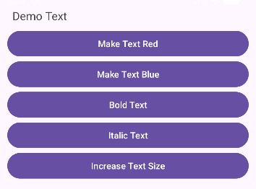
After changing the text size and the text color:
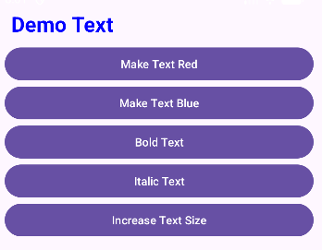
Q2: Find the “hello word” text in the XML document and modify the text.

MainActivity.java:
package com.example.demo;

import android.os.Bundle;
import androidx.appcompat.app.AppCompatActivity;

public class MainActivity extends AppCompatActivity {

@Override
protected void onCreate(Bundle savedInstanceState) {
super.onCreate(savedInstanceState);
setContentView(R.layout.activity_main);
}
}

activity_main.xml:
<?xml version="1.0" encoding="utf-8"?>
<androidx.constraintlayout.widget.ConstraintLayout xmlns:android="http://schemas.android.com/apk/res/android"
xmlns:app="http://schemas.android.com/apk/res-auto"
xmlns:tools="http://schemas.android.com/tools"
android:layout_width="match_parent"
android:layout_height="match_parent"
android:padding="16dp">

<TextView
android:layout_width="wrap_content"
android:layout_height="wrap_content"
android:layout_marginStart="148dp"
android:layout_marginTop="248dp"
android:layout_marginEnd="117dp"
android:layout_marginBottom="448dp"
android:text="Welcome to My App!"
app:layout_constraintBottom_toBottomOf="parent"
app:layout_constraintEnd_toEndOf="parent"
app:layout_constraintStart_toStartOf="parent"
app:layout_constraintTop_toTopOf="parent" />

</androidx.constraintlayout.widget.ConstraintLayout>

UI:
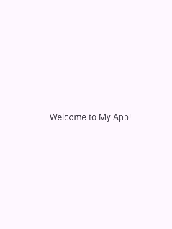

Lab 2: INTRODUCTION TO ACTIVITY AND LAYOUTS IN ANDROID

Q1: Create an app that illustrates that the activity lifecycle method being triggered by various action. Understand when onCreate(),onStart(),onResume event occur

MainActivity.java:
package com.example.demo;

import android.os.Bundle;
import android.widget.Toast;
import androidx.appcompat.app.AppCompatActivity;

public class MainActivity extends AppCompatActivity {

@Override
protected void onCreate(Bundle savedInstanceState) {
super.onCreate(savedInstanceState);
setContentView(R.layout.activity_main);
Toast.makeText(this, "onCreate() called", Toast.LENGTH_SHORT).show();
}

@Override
protected void onStart() {
super.onStart();
Toast.makeText(this, "onStart() called", Toast.LENGTH_SHORT).show();
}

@Override
protected void onResume() {
super.onResume();
Toast.makeText(this, "onResume() called", Toast.LENGTH_SHORT).show();
}
}

activity_main.xml:
<?xml version="1.0" encoding="utf-8"?>
<LinearLayout xmlns:android="http://schemas.android.com/apk/res/android"
android:layout_width="match_parent"
android:layout_height="match_parent"
android:gravity="center"
android:orientation="vertical">

<TextView
android:id="@+id/textView"
android:layout_width="wrap_content"
android:layout_height="wrap_content"
android:text="Activity Lifecycle Demo"
android:textSize="20sp"/>

</LinearLayout>

UI:
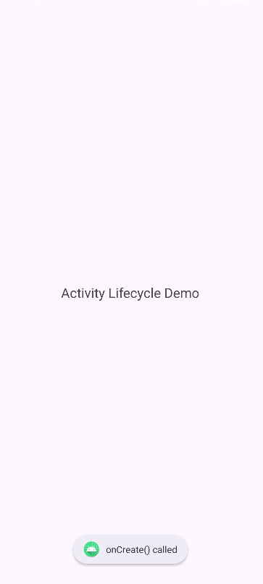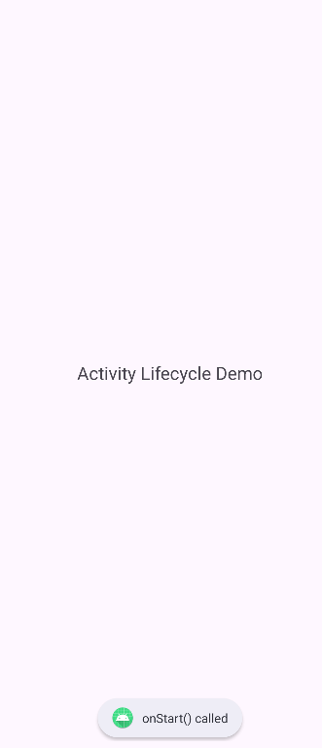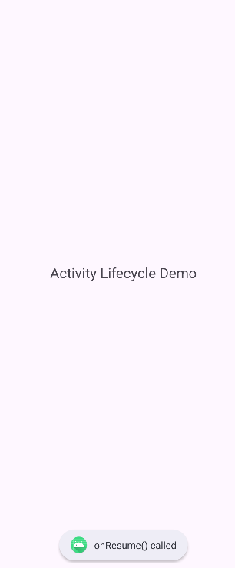

Q2: Create a Calculator app that does the function of multiplication, addition, division, subtraction but displays the result in the format of:-Num1 operator num2 = result. Back button on the next activity should get back to the calculator activity again.

MainActivity.java:
package com.example.demo;

import android.content.Intent;
import android.os.Bundle;
import android.view.View;
import android.widget.Button;
import android.widget.TextView;
import androidx.appcompat.app.AppCompatActivity;

import com.example.demo.ResultActivity;

public class MainActivity extends AppCompatActivity {

TextView display;
String num1 = "", num2 = "", operator = "";
boolean isSecondNumber = false;

@Override
protected void onCreate(Bundle savedInstanceState) {
super.onCreate(savedInstanceState);
setContentView(R.layout.activity_main);

display = findViewById(R.id.display);
}

public void onDigitClick(View view) {
Button btn = (Button) view;
if (!isSecondNumber) {
num1 += btn.getText().toString();
display.setText(num1);
} else {
num2 += btn.getText().toString();
display.setText(num2);
}
}

public void onOperatorClick(View view) {
Button btn = (Button) view;
operator = btn.getText().toString();
isSecondNumber = true;
}

public void onClearClick(View view) {
num1 = num2 = operator = "";
isSecondNumber = false;
display.setText("0");
}

public void onEqualClick(View view) {
if (num1.isEmpty() || num2.isEmpty()) return;

Intent intent = new Intent(this, ResultActivity.class);
intent.putExtra("num1", num1);
intent.putExtra("num2", num2);
intent.putExtra("operator", operator);
startActivity(intent);
}
}

activity_main.xml:
<?xml version="1.0" encoding="utf-8"?>
<LinearLayout xmlns:android="http://schemas.android.com/apk/res/android"
android:layout_width="match_parent"
android:layout_height="match_parent"
android:orientation="vertical"
android:padding="12dp">
<TextView
android:layout_width="match_parent"
android:layout_height="wrap_content"
android:text="Calculator"
android:textAlignment="center"
android:textSize="30sp"/>

<TextView
android:id="@+id/display"
android:layout_width="match_parent"
android:layout_height="50dp"
android:background="#DDDDDD"
android:gravity="end|center_vertical"
android:padding="10dp"
android:textSize="28sp"
android:text="0"/>

<GridLayout
android:layout_width="match_parent"
android:layout_height="wrap_content"
android:columnCount="4"
android:rowCount="5"
android:layout_marginTop="10dp">

<Button android:text="7" android:onClick="onDigitClick"/>
<Button android:text="8" android:onClick="onDigitClick"/>
<Button android:text="9" android:onClick="onDigitClick"/>
<Button android:text="÷" android:onClick="onOperatorClick"/>

<Button android:text="4" android:onClick="onDigitClick"/>
<Button android:text="5" android:onClick="onDigitClick"/>
<Button android:text="6" android:onClick="onDigitClick"/>
<Button android:text="×" android:onClick="onOperatorClick"/>

<Button android:text="1" android:onClick="onDigitClick"/>
<Button android:text="2" android:onClick="onDigitClick"/>
<Button android:text="3" android:onClick="onDigitClick"/>
<Button android:text="-" android:onClick="onOperatorClick"/>

<Button android:text="0" android:onClick="onDigitClick"/>
<Button android:text="C" android:onClick="onClearClick"/>
<Button android:text="=" android:onClick="onEqualClick"/>
<Button android:text="+" android:onClick="onOperatorClick"/>

</GridLayout>

</LinearLayout>

ResultAcitivity.java:
package com.example.demo;

import android.os.Bundle;
import android.widget.TextView;
import androidx.appcompat.app.AppCompatActivity;

public class ResultActivity extends AppCompatActivity {

@Override
protected void onCreate(Bundle savedInstanceState) {
super.onCreate(savedInstanceState);
setContentView(R.layout.activity_result);

TextView resultText = findViewById(R.id.resultText);

double n1 = Double.parseDouble(getIntent().getStringExtra("num1"));
double n2 = Double.parseDouble(getIntent().getStringExtra("num2"));
String op = getIntent().getStringExtra("operator");

double result = 0;
switch (op) {
case "+": result = n1 + n2; break;
case "-": result = n1 - n2; break;
case "×": result = n1 * n2; break;
case "÷": result = n2 != 0 ? n1 / n2 : 0; break;
}

resultText.setText(n1 + " " + op + " " + n2 + " = " + result);
}
}

activity_result.xml:
<?xml version="1.0" encoding="utf-8"?>
<LinearLayout xmlns:android="http://schemas.android.com/apk/res/android"
android:layout_width="match_parent"
android:layout_height="match_parent"
android:gravity="center"
android:orientation="vertical">

<TextView
android:id="@+id/resultText"
android:layout_width="wrap_content"
android:layout_height="wrap_content"
android:textSize="26sp"
android:textStyle="bold"/>

</LinearLayout>

UI:
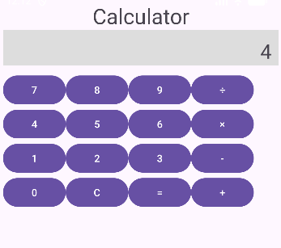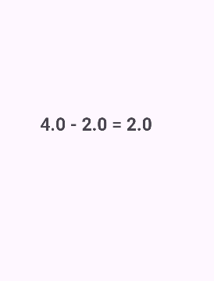

Q3: Create the following given scenario using linear and relative layout concept.
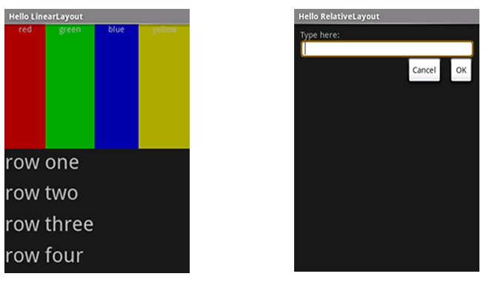
Linear Layout:

MainActivity.java:
package com.example.demo;

import android.os.Bundle;
import androidx.appcompat.app.AppCompatActivity;

public class MainActivity extends AppCompatActivity {

@Override
protected void onCreate(Bundle savedInstanceState) {
super.onCreate(savedInstanceState);
setContentView(R.layout.activity_main);
}
}

activity_main.xml:
<?xml version="1.0" encoding="utf-8"?>
<LinearLayout xmlns:android="http://schemas.android.com/apk/res/android"
android:layout_width="match_parent"
android:layout_height="match_parent"
android:orientation="vertical">
<TextView
android:layout_width="match_parent"
android:layout_height="wrap_content"
android:text="Hello Linear Layout"
android:textSize="20sp"
android:background="#8C000000"
android:textColor="@color/white" />

<LinearLayout
android:layout_width="match_parent"
android:layout_height="281dp"
android:orientation="horizontal">

<TextView
android:layout_width="0dp"
android:layout_height="match_parent"
android:layout_weight="1"
android:background="#FF0000"
android:textAlignment="center"
android:text="red"
android:textColor="#FFFFFF" />

<TextView
android:layout_width="0dp"
android:layout_height="match_parent"
android:layout_weight="1"
android:background="#00FF00"
android:textAlignment="center"
android:text="green"
android:textColor="#FFFFFF" />

<TextView
android:layout_width="0dp"
android:layout_height="match_parent"
android:layout_weight="1"
android:background="#0000FF"
android:textAlignment="center"
android:text="blue"
android:textColor="#FFFFFF" />

<TextView
android:layout_width="0dp"
android:layout_height="match_parent"
android:layout_weight="1"
android:background="#FFFF00"
android:textAlignment="center"
android:text="yellow"
android:textColor="#FFFFFF" />
</LinearLayout>

<LinearLayout
android:layout_width="match_parent"
android:layout_height="match_parent"
android:background="#222222"
android:orientation="vertical"
android:padding="16dp">

<TextView
android:layout_width="match_parent"
android:layout_height="0dp"
android:layout_weight="1"
android:text="row one"
android:textSize="22sp"
android:textColor="#FFFFFF"/>

<TextView
android:layout_width="match_parent"
android:layout_height="0dp"
android:layout_weight="1"
android:text="row two"
android:textSize="22sp"
android:textColor="#FFFFFF"/>

<TextView
android:layout_width="match_parent"
android:layout_height="0dp"
android:layout_weight="1"
android:text="row three"
android:textSize="22sp"
android:textColor="#FFFFFF"/>

<TextView
android:layout_width="match_parent"
android:layout_height="0dp"
android:layout_weight="1"
android:text="row four"
android:textSize="22sp"
android:textColor="#FFFFFF"/>

</LinearLayout>

</LinearLayout>

UI :
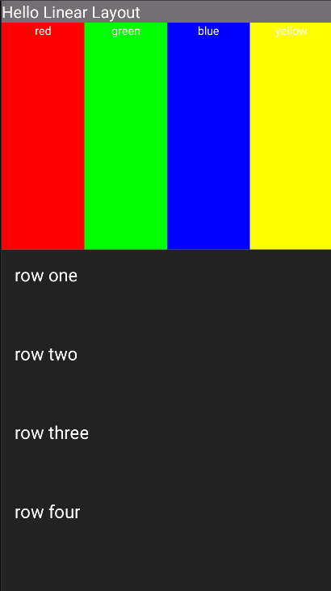

Relative Layout:

MainActivity.java:
package com.example.demo;

import android.os.Bundle;
import androidx.appcompat.app.AppCompatActivity;

public class MainActivity extends AppCompatActivity {

@Override
protected void onCreate(Bundle savedInstanceState) {
super.onCreate(savedInstanceState);
setContentView(R.layout.activity_main);
}
}

activity_main.xml:
<?xml version="1.0" encoding="utf-8"?>
<RelativeLayout xmlns:android="http://schemas.android.com/apk/res/android"
android:layout_width="match_parent"
android:layout_height="match_parent"
android:background="#111111"
>

<TextView
android:layout_width="match_parent"
android:layout_height="wrap_content"
android:text="Hello Relative Layout"
android:background="#69767474"
android:textColor="@color/white"
/>

<TextView
android:id="@+id/label"
android:layout_width="wrap_content"
android:layout_height="wrap_content"
android:text="Type here:"
android:textColor="#FFFFFF"
android:paddingLeft="16dp"
android:layout_marginTop="25dp"/>

<EditText
android:id="@+id/inputBox"
android:layout_width="match_parent"
android:layout_height="wrap_content"
android:layout_below="@id/label"
android:layout_marginTop="8dp"

android:background="@drawable/input_border"/>

<Button
android:id="@+id/cancelBtn"
android:layout_width="wrap_content"
android:layout_height="wrap_content"
android:layout_below="@id/inputBox"
android:layout_alignParentEnd="true"
android:layout_marginTop="14dp"
android:layout_marginEnd="121dp"
android:background="@drawable/flat_button"
android:text="Cancel"
android:textColor="@color/black" />

<Button
android:id="@+id/okBtn"
android:layout_width="wrap_content"
android:layout_height="wrap_content"
android:text="OK"
android:background="@drawable/flat_button"
android:textColor="@color/black"
android:layout_below="@id/inputBox"
android:layout_alignParentEnd="true"
android:layout_marginTop="12dp"
/>

</RelativeLayout>

input_border.xml:
<?xml version="1.0" encoding="utf-8"?>
<shape xmlns:android="http://schemas.android.com/apk/res/android">
<solid android:color="#FFFFFF"/>
<corners android:radius="8dp"/>
<stroke android:width="2dp" android:color="#FFD700"/>
<padding android:left="8dp" android:right="8dp" android:top="8dp" android:bottom="8dp"/>
</shape>

flat_button.xml:
<?xml version="1.0" encoding="utf-8"?>
<shape xmlns:android="http://schemas.android.com/apk/res/android">
<solid android:color="#E0E0E0"/>
<stroke android:width="1dp" android:color="#888888"/>
<corners android:radius="0dp"/>
</shape>

UI :
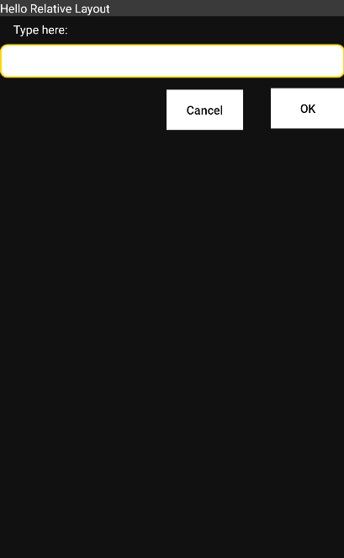

Q4: Create an app such that when the user click on the given URL typed by the user, it visits the corresponding page.

MainActivity.java:
package com.example.demo;

import android.content.Intent;
import android.net.Uri;
import android.os.Bundle;
import android.view.View;
import android.widget.EditText;
import android.widget.Toast;
import androidx.appcompat.app.AppCompatActivity;

public class MainActivity extends AppCompatActivity {

EditText urlInput;

@Override
protected void onCreate(Bundle savedInstanceState) {
super.onCreate(savedInstanceState);
setContentView(R.layout.activity_main);

urlInput = findViewById(R.id.urlInput);
}

public void openWebsite(View view) {
String url = urlInput.getText().toString().trim();

if (url.isEmpty()) {
Toast.makeText(this, "Please enter a URL", Toast.LENGTH_SHORT).show();
return;
}

if (!url.startsWith("http://") && !url.startsWith("https://")) {
url = "https://" + url;
}

Intent intent = new Intent(Intent.ACTION_VIEW, Uri.parse(url));
startActivity(intent);
}
}

activity_main.xml:
<?xml version="1.0" encoding="utf-8"?>
<LinearLayout xmlns:android="http://schemas.android.com/apk/res/android"
android:layout_width="match_parent"
android:layout_height="match_parent"
android:orientation="vertical"
android:padding="16dp">

<EditText
android:id="@+id/urlInput"
android:layout_width="match_parent"
android:layout_height="wrap_content"
android:hint="Enter URL (e.g. google.com)"
android:inputType="textUri"/>

<Button
android:layout_width="match_parent"
android:layout_height="wrap_content"
android:text="Go to Website"
android:textColor="@color/black"
android:onClick="openWebsite"/>

</LinearLayout>

UI:
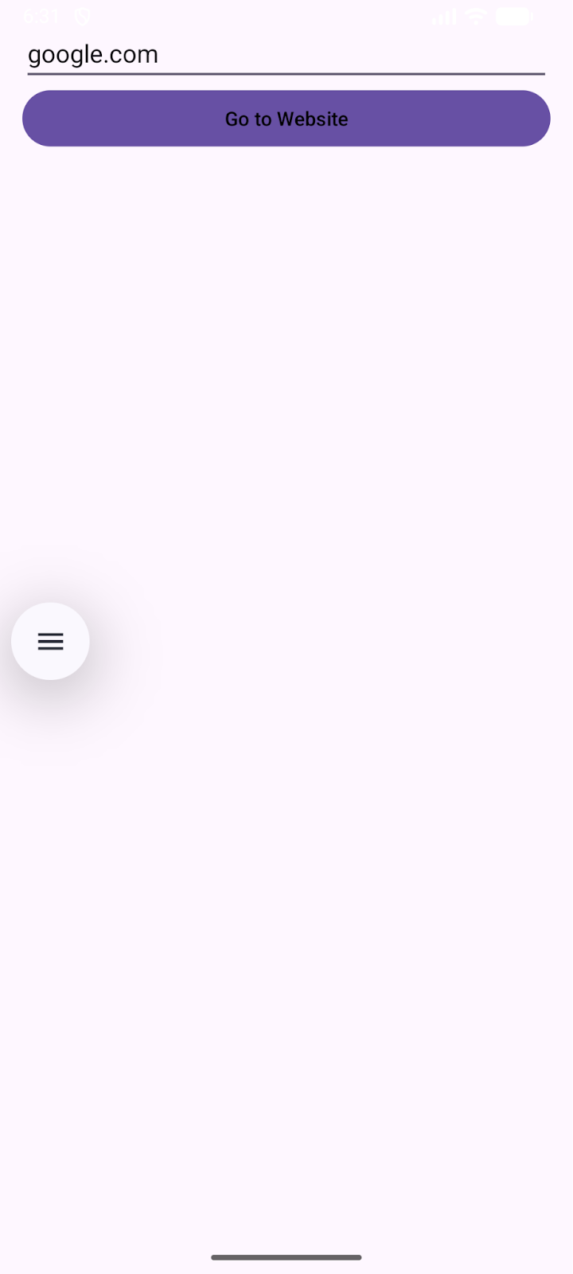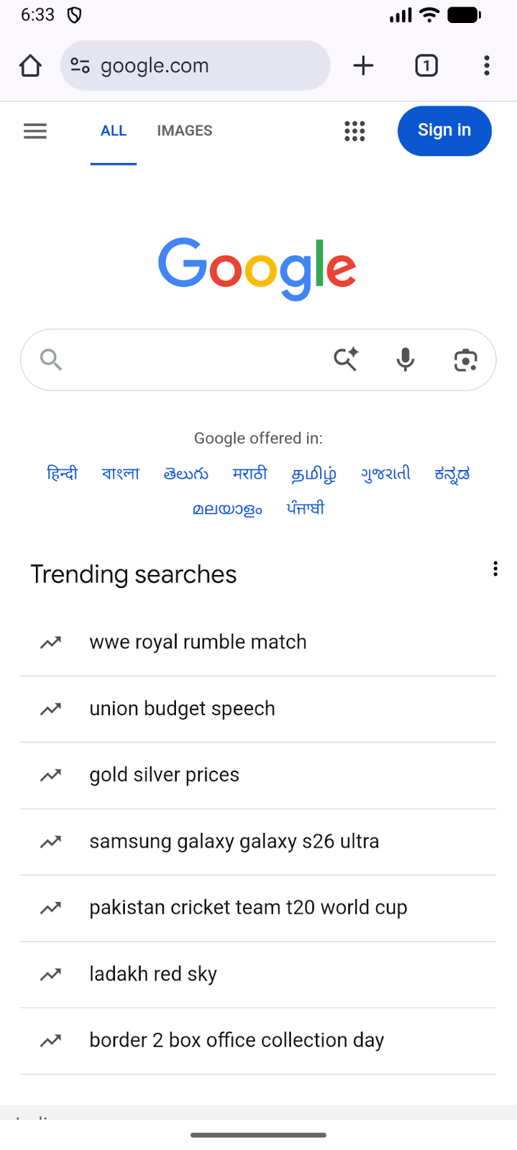

Lab 3: ACTIVITY AND LAYOUT CONTINUED

Q1: Using given scenario develop an application to perform following layout operations:
▪ List view ▪ Grid view ▪ Tab layout ▪ Table layout
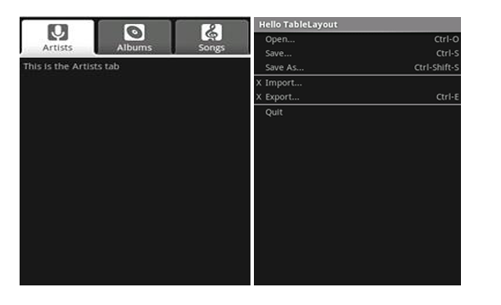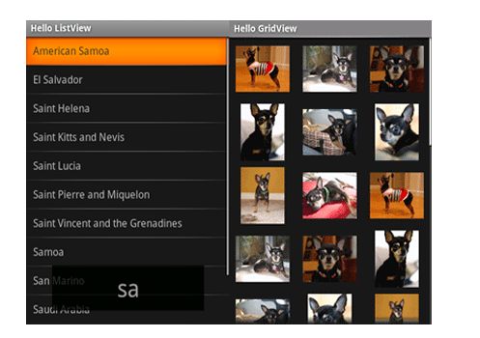
MainActivity.java:
package com.example.demo;

import android.os.Bundle;
import androidx.appcompat.app.AppCompatActivity;
import androidx.viewpager2.widget.ViewPager2;
import com.google.android.material.tabs.TabLayout;
import com.google.android.material.tabs.TabLayoutMediator;

public class MainActivity extends AppCompatActivity {

@Override
protected void onCreate(Bundle savedInstanceState) {
super.onCreate(savedInstanceState);
setContentView(R.layout.activity_main);

TabLayout tabLayout = findViewById(R.id.tabLayout);
ViewPager2 viewPager = findViewById(R.id.viewPager);

viewPager.setAdapter(new ViewPagerAdapter(this));

new TabLayoutMediator(tabLayout, viewPager, (tab, position) -> {
if (position == 0) tab.setText("Artists");
else if (position == 1) tab.setText("Albums");
else tab.setText("Songs");
}).attach();
}
}

AlbumsFragment.java:
package com.example.demo;

import android.os.Bundle;
import android.view.*;
import android.widget.GridView;
import androidx.fragment.app.Fragment;

public class AlbumsFragment extends Fragment {

int[] images = {
R.drawable.dog1, R.drawable.dog2, R.drawable.dog3,
R.drawable.dog4, R.drawable.dog5, R.drawable.dog6
};

@Override
public View onCreateView(LayoutInflater inflater, ViewGroup container, Bundle savedInstanceState) {
View v = inflater.inflate(R.layout.fragment_albums, container, false);
GridView gridView = v.findViewById(R.id.gridView);
gridView.setAdapter(new ImageAdapter(getContext(), images));
return v;
}
}

ArtistsFragment.java:
package com.example.demo;

import android.os.Bundle;
import android.view.*;
import android.widget.*;
import androidx.fragment.app.Fragment;

public class ArtistsFragment extends Fragment {

@Override
public View onCreateView(LayoutInflater inflater, ViewGroup container, Bundle savedInstanceState) {
View v = inflater.inflate(R.layout.fragment_artists, container, false);

String[] countries = {
"American Samoa","El Salvador","Saint Helena",
"Saint Kitts and Nevis","Saint Lucia","Saint Pierre and Miquelon",
"Saint Vincent and the Grenadines","Samoa","San Marino","Saudi Arabia"
};

ListView listView = v.findViewById(R.id.listView);
ArrayAdapter<String> adapter = new ArrayAdapter<>(getContext(),
R.layout.list_item_white,
R.id.itemText,
countries);

listView.setAdapter(adapter);

return v;
}
}

ImageAdapter.java:
package com.example.demo;

import android.content.Context;
import android.view.*;
import android.widget.*;

public class ImageAdapter extends BaseAdapter {

Context context;
int[] images;

public ImageAdapter(Context c, int[] imgs) {
context = c;
images = imgs;
}

public int getCount() { return images.length; }
public Object getItem(int pos) { return images[pos]; }
public long getItemId(int pos) { return pos; }

public View getView(int pos, View convertView, ViewGroup parent) {
ImageView iv = new ImageView(context);
iv.setImageResource(images[pos]);
iv.setLayoutParams(new GridView.LayoutParams(300, 300));
iv.setScaleType(ImageView.ScaleType.CENTER_CROP);
return iv;
}
}

SongsFragment.java:
package com.example.demo;

import android.os.Bundle;
import android.view.*;
import androidx.fragment.app.Fragment;

public class SongsFragment extends Fragment {
@Override
public View onCreateView(LayoutInflater inflater, ViewGroup container, Bundle savedInstanceState) {
return inflater.inflate(R.layout.fragment_songs, container, false);
}
}

ViewPagerAdapter.java:
package com.example.demo;

import androidx.annotation.NonNull;
import androidx.fragment.app.Fragment;
import androidx.fragment.app.FragmentActivity;
import androidx.viewpager2.adapter.FragmentStateAdapter;

public class ViewPagerAdapter extends FragmentStateAdapter {

public ViewPagerAdapter(@NonNull FragmentActivity fa) {
super(fa);
}

@NonNull
@Override
public Fragment createFragment(int position) {
if (position == 0) return new ArtistsFragment();
else if (position == 1) return new AlbumsFragment();
else return new SongsFragment();
}

@Override
public int getItemCount() {
return 3;
}
}

activity_main.xml:
<LinearLayout xmlns:android="http://schemas.android.com/apk/res/android"
xmlns:app="http://schemas.android.com/apk/res-auto"
android:layout_width="match_parent"
android:layout_height="match_parent"
android:orientation="vertical">

<com.google.android.material.tabs.TabLayout
android:id="@+id/tabLayout"
android:layout_width="match_parent"
android:layout_height="wrap_content"
android:background="#333333"
app:tabTextColor="@color/white"
app:tabSelectedTextColor="#FFFFFF"
app:tabIndicatorColor="#FFFFFF"/>

<androidx.viewpager2.widget.ViewPager2
android:id="@+id/viewPager"
android:layout_width="match_parent"
android:layout_height="match_parent"
/>
</LinearLayout>

fragment_albums.xml:
<GridView xmlns:android="http://schemas.android.com/apk/res/android"
android:id="@+id/gridView"
android:layout_width="match_parent"
android:layout_height="match_parent"
android:numColumns="3"
android:verticalSpacing="8dp"
android:horizontalSpacing="8dp"
android:background="#111111"
android:padding="8dp"/>

fragment_artists.xml:
<ListView xmlns:android="http://schemas.android.com/apk/res/android"
android:id="@+id/listView"
android:layout_width="match_parent"
android:layout_height="match_parent"
android:background="#111111"
android:divider="#444444"
android:dividerHeight="1dp"/>

fragment_songs.xml:
<TableLayout xmlns:android="http://schemas.android.com/apk/res/android"
android:layout_width="match_parent"
android:layout_height="match_parent"
android:background="#111111"
android:stretchColumns="*"
android:padding="10dp">

<TableRow>
<TextView android:text="Open..." android:textColor="#FFFFFF"/>
<TextView android:text="Ctrl+O" android:textColor="#AAAAAA"/>
</TableRow>

<TableRow>
<TextView android:text="Save..." android:textColor="#FFFFFF"/>
<TextView android:text="Ctrl+S" android:textColor="#AAAAAA"/>
</TableRow>

<TableRow>
<TextView android:text="Import..." android:textColor="#FFFFFF"/>
<TextView android:text="Ctrl+I" android:textColor="#AAAAAA"/>
</TableRow>

<TableRow>
<TextView android:text="Export..." android:textColor="#FFFFFF"/>
<TextView android:text="Ctrl+E" android:textColor="#AAAAAA"/>
</TableRow>

<TableRow>
<TextView android:text="Quit" android:textColor="#FFFFFF"/>
<TextView android:text="Ctrl+Q" android:textColor="#AAAAAA"/>
</TableRow>
</TableLayout>

list_item_white.xml:
<?xml version="1.0" encoding="utf-8"?>
<TextView xmlns:android="http://schemas.android.com/apk/res/android"
android:id="@+id/itemText"
android:layout_width="match_parent"
android:layout_height="wrap_content"
android:textColor="#FFFFFF"
android:textSize="16sp"
android:padding="12dp"
android:background="#111111"/>

UI:
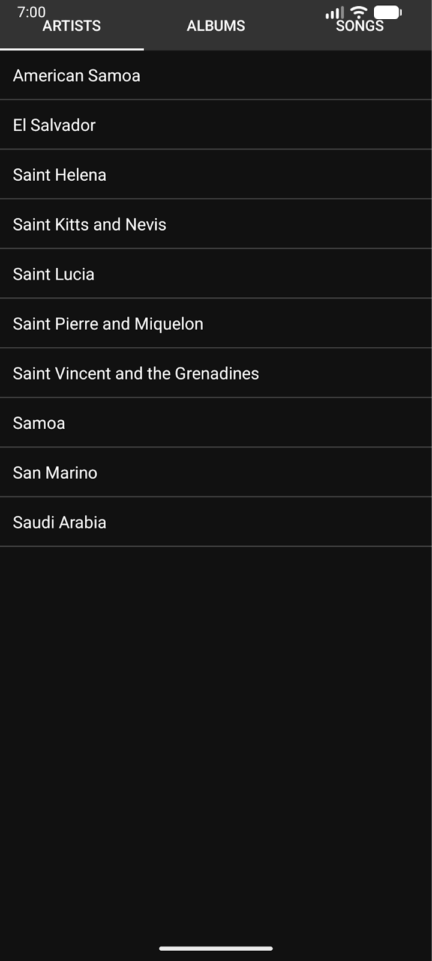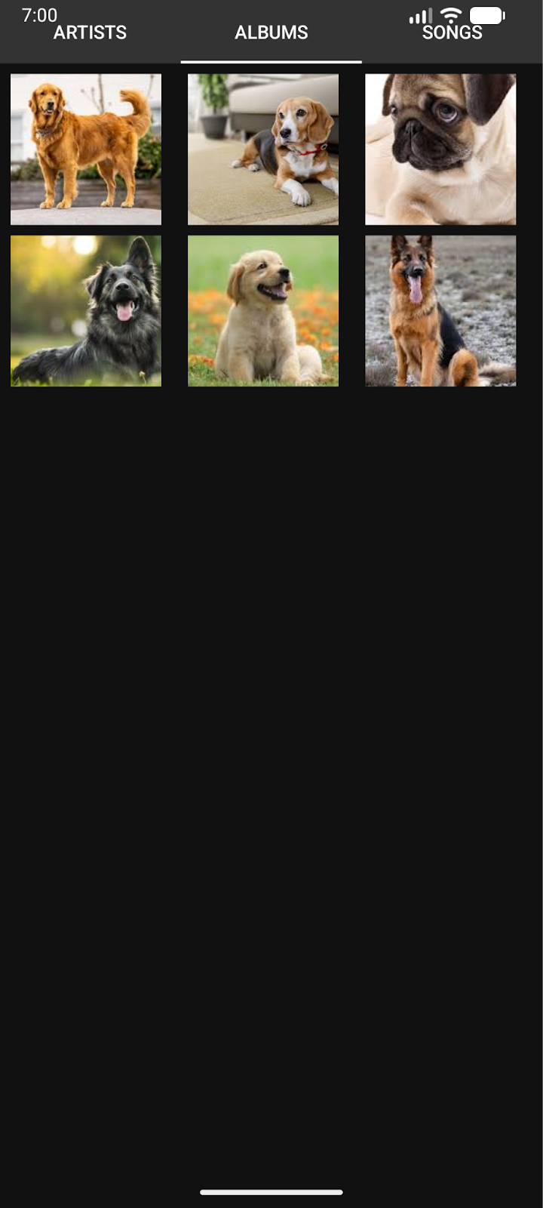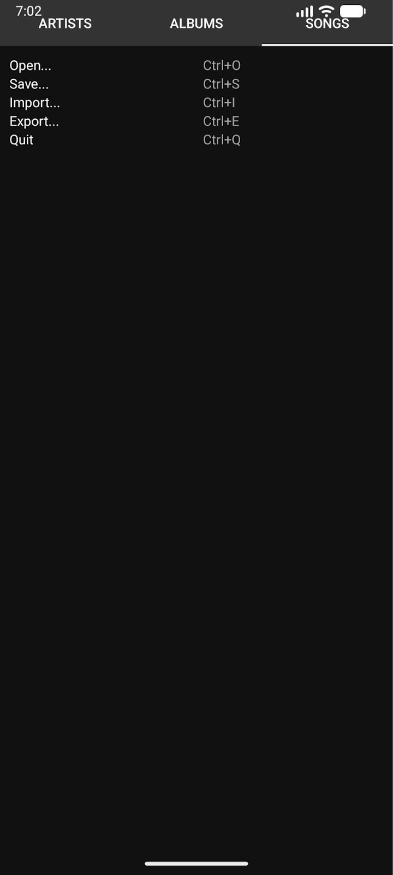

Q2: Write a program to list different sports, and when a sport is selected, display a message showing the selected sport.

MainActivity.java:
package com.example.demo;

import android.os.Bundle;
import android.view.View;
import android.widget.ArrayAdapter;
import android.widget.ListView;
import android.widget.Toast;

import androidx.appcompat.app.AppCompatActivity;

public class MainActivity extends AppCompatActivity {

ListView sportsListView;

@Override
protected void onCreate(Bundle savedInstanceState) {
super.onCreate(savedInstanceState);
setContentView(R.layout.activity_main);

sportsListView = findViewById(R.id.sportsListView);

String[] sports = {
"Cricket",
"Football",
"Tennis",
"Basketball",
"Hockey",
"Badminton",
"Volleyball"
};

ArrayAdapter<String> adapter = new ArrayAdapter<>(
this,
android.R.layout.simple_list_item_1,
sports
);

sportsListView.setAdapter(adapter);

sportsListView.setOnItemClickListener((parent, view, position, id) -> {
String selectedSport = sports[position];
Toast.makeText(MainActivity.this,
"Selected Sport: " + selectedSport,
Toast.LENGTH_SHORT).show();
});
}
}

activity_main.xml:
<?xml version="1.0" encoding="utf-8"?>
<ListView xmlns:android="http://schemas.android.com/apk/res/android"
android:id="@+id/sportsListView"
android:layout_width="match_parent"
android:layout_height="match_parent" />

UI:

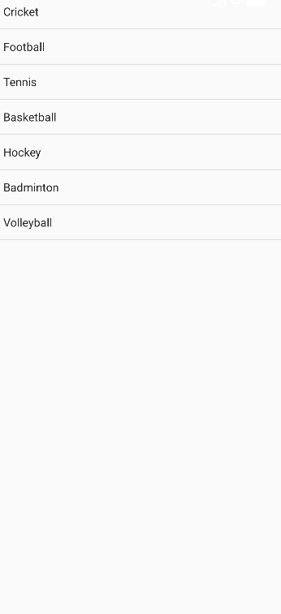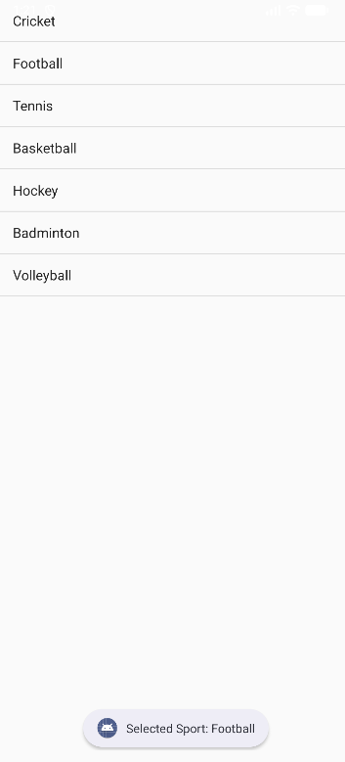

Q3: Design an news application and Implement the navigation between sections like Top Stories, Sports, and Entertainment using tab layout.

MainActivity.java:
package com.example.demo;

import android.os.Bundle;
import androidx.appcompat.app.AppCompatActivity;
import androidx.viewpager.widget.ViewPager;
import com.google.android.material.tabs.TabLayout;

public class MainActivity extends AppCompatActivity {

@Override
protected void onCreate(Bundle savedInstanceState) {
super.onCreate(savedInstanceState);
setContentView(R.layout.activity_main);

TabLayout tabLayout = findViewById(R.id.tabLayout);
ViewPager viewPager = findViewById(R.id.viewPager);

ViewPagerAdapter adapter = new ViewPagerAdapter(getSupportFragmentManager());
adapter.addFragment(new TopStoriesFragment(), "Top Stories");
adapter.addFragment(new SportsFragment(), "Sports");
adapter.addFragment(new EntertainmentFragment(), "Entertainment");

viewPager.setAdapter(adapter);
tabLayout.setupWithViewPager(viewPager);
}
}

EntertainmentFragment.java:
package com.example.demo;

import android.os.Bundle;
import android.view.LayoutInflater;
import android.view.View;
import android.view.ViewGroup;
import android.widget.ArrayAdapter;
import android.widget.ListView;

import androidx.fragment.app.Fragment;

public class EntertainmentFragment extends Fragment {

@Override
public View onCreateView(LayoutInflater inflater, ViewGroup container, Bundle savedInstanceState) {
View v = inflater.inflate(R.layout.fragment_list, container, false);
ListView listView = v.findViewById(R.id.listView);

String[] entertainmentNews = {
"New Movie Releases",
"Celebrity Interviews",
"Music Festival Updates",
"Award Show Highlights"
};

ArrayAdapter<String> adapter = new ArrayAdapter<>(getContext(),
android.R.layout.simple_list_item_1, entertainmentNews);

listView.setAdapter(adapter);
return v;
}
}

SportsFragment.java:
package com.example.demo;

import android.os.Bundle;
import android.view.LayoutInflater;
import android.view.View;
import android.view.ViewGroup;
import android.widget.ArrayAdapter;
import android.widget.ListView;

import androidx.fragment.app.Fragment;

public class SportsFragment extends Fragment {

@Override
public View onCreateView(LayoutInflater inflater, ViewGroup container, Bundle savedInstanceState) {
View v = inflater.inflate(R.layout.fragment_list, container, false);
ListView listView = v.findViewById(R.id.listView);

String[] sportsNews = {
"Football World Cup Updates",
"Cricket Series Highlights",
"Olympics Preparation",
"Tennis Grand Slam News"
};

ArrayAdapter<String> adapter = new ArrayAdapter<>(getContext(),
android.R.layout.simple_list_item_1, sportsNews);

listView.setAdapter(adapter);
return v;
}
}

TopStoriesFragment.java:
package com.example.demo;

import android.os.Bundle;
import android.view.LayoutInflater;
import android.view.View;
import android.view.ViewGroup;
import android.widget.ArrayAdapter;
import android.widget.ListView;

import androidx.fragment.app.Fragment;

public class TopStoriesFragment extends Fragment {

@Override
public View onCreateView(LayoutInflater inflater, ViewGroup container, Bundle savedInstanceState) {
View v = inflater.inflate(R.layout.fragment_list, container, false);
ListView listView = v.findViewById(R.id.listView);

String[] news = {
"Global Market Updates",
"New Technology Trends",
"Political Developments",
"Climate Change News"
};

ArrayAdapter<String> adapter = new ArrayAdapter<>(getContext(),
android.R.layout.simple_list_item_1, news);

listView.setAdapter(adapter);
return v;
}
}

ViewPagerAdapter.java:
package com.example.demo;

import androidx.annotation.NonNull;
import androidx.fragment.app.Fragment;
import androidx.fragment.app.FragmentManager;
import androidx.fragment.app.FragmentPagerAdapter;
import java.util.ArrayList;
import java.util.List;

public class ViewPagerAdapter extends FragmentPagerAdapter {

private final List<Fragment> fragmentList = new ArrayList<>();
private final List<String> fragmentTitleList = new ArrayList<>();

public ViewPagerAdapter(FragmentManager manager) {
super(manager);
}

@NonNull
@Override
public Fragment getItem(int position) {
return fragmentList.get(position);
}

@Override
public int getCount() {
return fragmentList.size();
}

public void addFragment(Fragment fragment, String title) {
fragmentList.add(fragment);
fragmentTitleList.add(title);
}

@Override
public CharSequence getPageTitle(int position) {
return fragmentTitleList.get(position);
}
}

activity_main.xml:
<?xml version="1.0" encoding="utf-8"?>
<LinearLayout xmlns:android="http://schemas.android.com/apk/res/android"
xmlns:app="http://schemas.android.com/apk/res-auto"
android:layout_width="match_parent"
android:layout_height="match_parent"
android:orientation="vertical">

<com.google.android.material.tabs.TabLayout
android:id="@+id/tabLayout"
android:layout_width="match_parent"
android:layout_height="wrap_content" />

<androidx.viewpager.widget.ViewPager
android:id="@+id/viewPager"
android:layout_width="match_parent"
android:layout_height="match_parent"/>

</LinearLayout>

fragment_list.xml:
<ListView xmlns:android="http://schemas.android.com/apk/res/android"
android:id="@+id/listView"
android:layout_width="match_parent"
android:layout_height="match_parent"/>

UI:
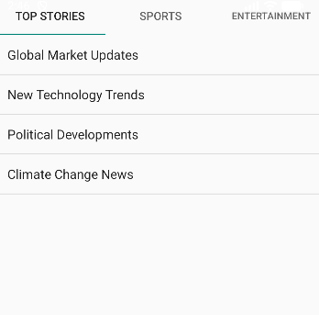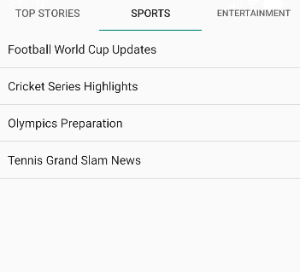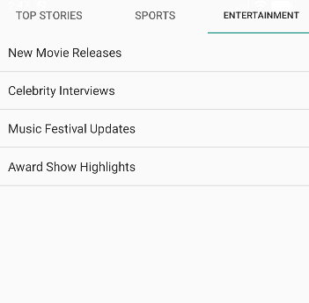
Lab 4: INPUT CONTROLS IN ANDROID

Q1: Develop a "Test App" that includes a layout with a Button and a ToggleButton. When each button is clicked, a custom Toast message should be displayed with different images as their content.

MainActivity.java:
package com.example.demo;

import android.os.Bundle;
import android.view.LayoutInflater;
import android.view.View;
import android.widget.Button;
import android.widget.ImageView;
import android.widget.TextView;
import android.widget.Toast;
import android.widget.ToggleButton;

import androidx.appcompat.app.AppCompatActivity;

public class MainActivity extends AppCompatActivity {

Button btnShow;
ToggleButton toggleShow;

@Override
protected void onCreate(Bundle savedInstanceState) {
super.onCreate(savedInstanceState);
setContentView(R.layout.activity_main);

btnShow = findViewById(R.id.btnShow);
toggleShow = findViewById(R.id.toggleShow);

btnShow.setOnClickListener(v -> showCustomToast("Button Clicked!", R.drawable.button_image));

toggleShow.setOnCheckedChangeListener((buttonView, isChecked) -> {
if (isChecked) {
showCustomToast("Toggle ON", R.drawable.toggle_on);
} else {
showCustomToast("Toggle OFF", R.drawable.toggle_off);
}
});
}

private void showCustomToast(String message, int imageRes) {
LayoutInflater inflater = getLayoutInflater();
View layout = inflater.inflate(R.layout.custom_toast, null);

ImageView image = layout.findViewById(R.id.toastImage);
TextView text = layout.findViewById(R.id.toastText);

image.setImageResource(imageRes);
text.setText(message);

Toast toast = new Toast(getApplicationContext());
toast.setDuration(Toast.LENGTH_SHORT);
toast.setView(layout);
toast.show();
}
}

activity_main.xml:
<?xml version="1.0" encoding="utf-8"?>
<LinearLayout xmlns:android="http://schemas.android.com/apk/res/android"
android:layout_width="match_parent"
android:layout_height="match_parent"
android:gravity="center"
android:orientation="vertical"
android:padding="20dp">

<Button
android:id="@+id/btnShow"
android:layout_width="wrap_content"
android:layout_height="wrap_content"
android:text="Show Toast" />

<ToggleButton
android:id="@+id/toggleShow"
android:layout_width="wrap_content"
android:layout_height="wrap_content"
android:textOn="Toast ON"
android:textOff="Toast OFF"
android:layout_marginTop="20dp" />

</LinearLayout>

custom_toast.xml:
<?xml version="1.0" encoding="utf-8"?>
<LinearLayout xmlns:android="http://schemas.android.com/apk/res/android"
android:layout_width="wrap_content"
android:layout_height="wrap_content"
android:orientation="vertical"
android:padding="10dp"
android:background="#DD000000"
android:gravity="center">

<ImageView
android:id="@+id/toastImage"
android:layout_width="80dp"
android:layout_height="80dp"
android:src="@drawable/ic_launcher_foreground" />

<TextView
android:id="@+id/toastText"
android:layout_width="wrap_content"
android:layout_height="wrap_content"
android:textColor="#FFFFFF"
android:textSize="16sp"
android:paddingTop="5dp"/>
</LinearLayout>

UI:
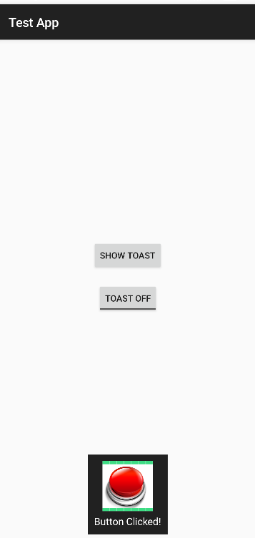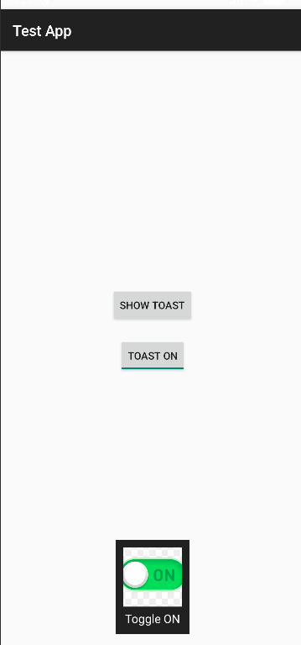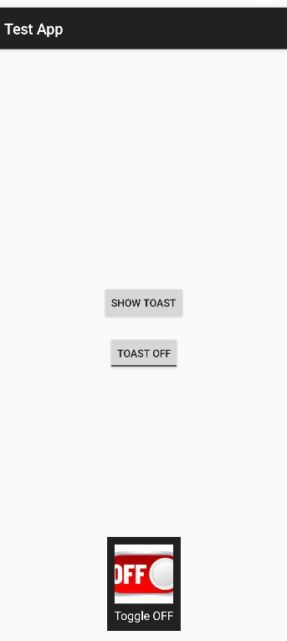

Q2: Create an app that contains a view with multiple buttons, each labeled with different Android versions. When a button is clicked, a Toast message should appear, displaying the corresponding Android version's name along with its associated icon.

MainActivity.java:
package com.example.demo;

import android.os.Bundle;
import android.view.LayoutInflater;
import android.view.View;
import android.widget.Button;
import android.widget.ImageView;
import android.widget.TextView;
import android.widget.Toast;

import androidx.appcompat.app.AppCompatActivity;

public class MainActivity extends AppCompatActivity {

@Override
protected void onCreate(Bundle savedInstanceState) {
super.onCreate(savedInstanceState);
setContentView(R.layout.activity_main);

findViewById(R.id.btnCupcake).setOnClickListener(v ->
showToast("Android Cupcake", R.drawable.cupcake));

findViewById(R.id.btnKitKat).setOnClickListener(v ->
showToast("Android KitKat", R.drawable.kitkat));

findViewById(R.id.btnLollipop).setOnClickListener(v ->
showToast("Android Lollipop", R.drawable.lollipop));

findViewById(R.id.btnPie).setOnClickListener(v ->
showToast("Android Pie", R.drawable.pie));
}

private void showToast(String message, int imageRes) {
LayoutInflater inflater = getLayoutInflater();
View layout = inflater.inflate(R.layout.custom_toast, null);

ImageView image = layout.findViewById(R.id.toastImage);
TextView text = layout.findViewById(R.id.toastText);

image.setImageResource(imageRes);
text.setText(message);

Toast toast = new Toast(getApplicationContext());
toast.setDuration(Toast.LENGTH_SHORT);
toast.setView(layout);
toast.show();
}
}

activity_main.xml:
<?xml version="1.0" encoding="utf-8"?>
<ScrollView xmlns:android="http://schemas.android.com/apk/res/android"
android:layout_width="match_parent"
android:layout_height="match_parent">

<LinearLayout
android:layout_width="match_parent"
android:layout_height="wrap_content"
android:orientation="vertical"
android:gravity="center"
android:padding="20dp">

<Button
android:id="@+id/btnCupcake"
android:layout_width="match_parent"
android:layout_height="wrap_content"
android:text="Android 1.5 - Cupcake"/>

<Button
android:id="@+id/btnKitKat"
android:layout_width="match_parent"
android:layout_height="wrap_content"
android:text="Android 4.4 - KitKat"
android:layout_marginTop="10dp"/>

<Button
android:id="@+id/btnLollipop"
android:layout_width="match_parent"
android:layout_height="wrap_content"
android:text="Android 5.0 - Lollipop"
android:layout_marginTop="10dp"/>

<Button
android:id="@+id/btnPie"
android:layout_width="match_parent"
android:layout_height="wrap_content"
android:text="Android 9 - Pie"
android:layout_marginTop="10dp"/>

</LinearLayout>
</ScrollView>

custom_toast.xml:
<?xml version="1.0" encoding="utf-8"?>
<LinearLayout xmlns:android="http://schemas.android.com/apk/res/android"
android:layout_width="wrap_content"
android:layout_height="wrap_content"
android:orientation="horizontal"
android:padding="10dp"
android:background="#DD000000"
android:gravity="center_vertical">

<ImageView
android:id="@+id/toastImage"
android:layout_width="50dp"
android:layout_height="50dp"
android:layout_marginEnd="10dp"/>

<TextView
android:id="@+id/toastText"
android:layout_width="wrap_content"
android:layout_height="wrap_content"
android:textColor="#FFFFFF"
android:textSize="16sp"/>
</LinearLayout>

UI:
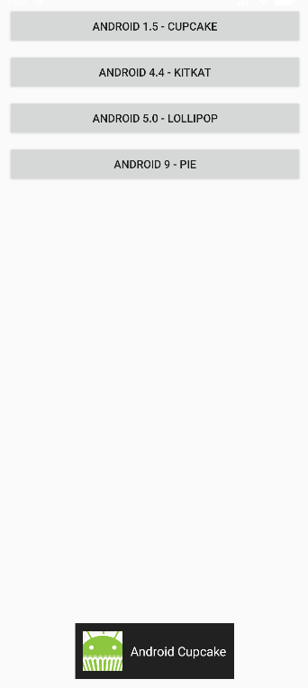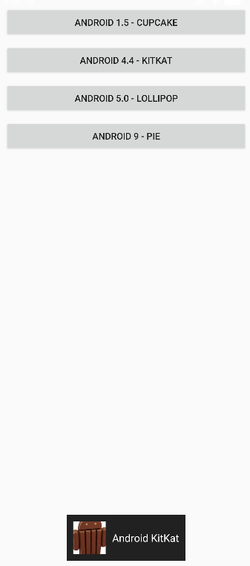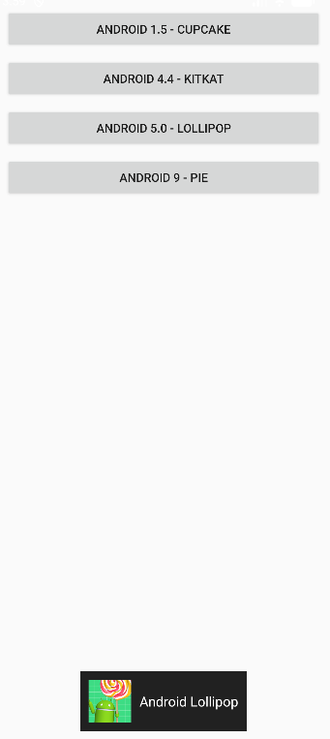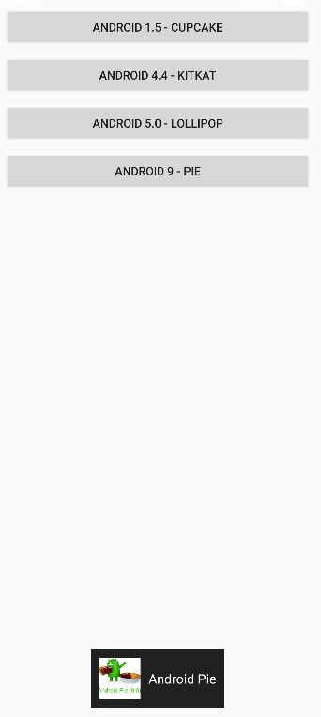

Q3: Develop a view with a ToggleButton labeled "Current Mode" that has two states: "Wi-Fi" and "Mobile Data." Based on the state of the toggle button, an image corresponding to the selected mode should appear, and a Toast message should display the current mode. Additionally, when the user clicks the "Change Mode" button, the app should switch to the corresponding mode and update the image accordingly.

MainActivity.java:
package com.example.demo;

import android.os.Bundle;
import android.widget.Button;
import android.widget.ImageView;
import android.widget.Toast;
import android.widget.ToggleButton;

import androidx.appcompat.app.AppCompatActivity;

public class MainActivity extends AppCompatActivity {

ToggleButton toggleMode;
ImageView modeImage;
Button btnChange;

@Override
protected void onCreate(Bundle savedInstanceState) {
super.onCreate(savedInstanceState);
setContentView(R.layout.activity_main);

toggleMode = findViewById(R.id.toggleMode);
modeImage = findViewById(R.id.modeImage);
btnChange = findViewById(R.id.btnChange);

toggleMode.setOnCheckedChangeListener((buttonView, isChecked) -> {
if (isChecked) {
modeImage.setImageResource(R.drawable.wifi);
Toast.makeText(this, "Current Mode: Wi-Fi", Toast.LENGTH_SHORT).show();
} else {
modeImage.setImageResource(R.drawable.mobile_data);
Toast.makeText(this, "Current Mode: Mobile Data", Toast.LENGTH_SHORT).show();
}
});

btnChange.setOnClickListener(v -> {
toggleMode.toggle();
});
}
}

activity_main.xml:
<?xml version="1.0" encoding="utf-8"?>
<LinearLayout xmlns:android="http://schemas.android.com/apk/res/android"
android:layout_width="match_parent"
android:layout_height="match_parent"
android:orientation="vertical"
android:gravity="center"
android:padding="24dp">

<ToggleButton
android:id="@+id/toggleMode"
android:layout_width="wrap_content"
android:layout_height="wrap_content"
android:textOn="Wi-Fi"
android:textOff="Mobile Data"
android:text="Current Mode" />

<ImageView
android:id="@+id/modeImage"
android:layout_width="150dp"
android:layout_height="150dp"
android:layout_marginTop="24dp"
android:src="@drawable/mobile_data" />

<Button
android:id="@+id/btnChange"
android:layout_width="wrap_content"
android:layout_height="wrap_content"
android:text="Change Mode"
android:layout_marginTop="24dp"/>

</LinearLayout>

UI:
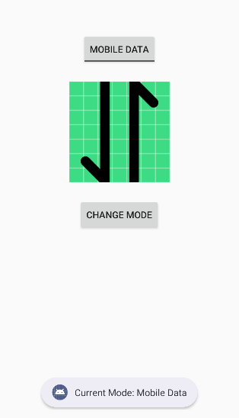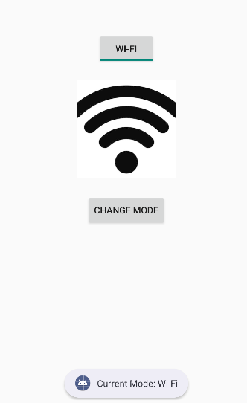

Q4: Create a “Food Ordering App” which lists food items with check boxes. Once the user checks /unchecks the item and click on the submit button display the items ordered along with cost of each item and total cost in a new activity. Once the user clicks on the submit button he/she should not be allowed to change the order i.e. he should not be allowed to change the state of the items checked.

MainActivity.java:
package com.example.demo;

import android.content.Intent;
import android.os.Bundle;
import android.widget.Button;
import android.widget.CheckBox;

import androidx.appcompat.app.AppCompatActivity;

public class MainActivity extends AppCompatActivity {

CheckBox cbBurger, cbPizza, cbPasta, cbSandwich, cbCoffee;
Button btnSubmit;

@Override
protected void onCreate(Bundle savedInstanceState) {
super.onCreate(savedInstanceState);
setContentView(R.layout.activity_main);

cbBurger = findViewById(R.id.cbBurger);
cbPizza = findViewById(R.id.cbPizza);
cbPasta = findViewById(R.id.cbPasta);
cbSandwich = findViewById(R.id.cbSandwich);
cbCoffee = findViewById(R.id.cbCoffee);
btnSubmit = findViewById(R.id.btnSubmit);

btnSubmit.setOnClickListener(v -> {

StringBuilder orderDetails = new StringBuilder();
int total = 0;

if (cbBurger.isChecked()) {
orderDetails.append("Burger - ₹120\n");
total += 120;
}
if (cbPizza.isChecked()) {
orderDetails.append("Pizza - ₹250\n");
total += 250;
}
if (cbPasta.isChecked()) {
orderDetails.append("Pasta - ₹180\n");
total += 180;
}
if (cbSandwich.isChecked()) {
orderDetails.append("Sandwich - ₹100\n");
total += 100;
}
if (cbCoffee.isChecked()) {
orderDetails.append("Coffee - ₹80\n");
total += 80;
}

Intent intent = new Intent(MainActivity.this, ResultActivity.class);
intent.putExtra("order", orderDetails.toString());
intent.putExtra("total", total);
startActivity(intent);

cbBurger.setEnabled(false);
cbPizza.setEnabled(false);
cbPasta.setEnabled(false);
cbSandwich.setEnabled(false);
cbCoffee.setEnabled(false);
btnSubmit.setEnabled(false);
});
}
}

activity_main.xml:
<?xml version="1.0" encoding="utf-8"?>
<ScrollView xmlns:android="http://schemas.android.com/apk/res/android"
android:layout_width="match_parent"
android:layout_height="match_parent">

<LinearLayout
android:layout_width="match_parent"
android:layout_height="wrap_content"
android:orientation="vertical"
android:padding="20dp">

<TextView
android:text="Select Your Food"
android:textSize="22sp"
android:textStyle="bold"
android:paddingBottom="16dp" android:layout_height="wrap_content" android:layout_width="wrap_content"/>

<CheckBox
android:id="@+id/cbBurger"
android:text="Burger - ₹120" android:layout_height="wrap_content" android:layout_width="wrap_content"/>

<CheckBox
android:id="@+id/cbPizza"
android:text="Pizza - ₹250" android:layout_height="wrap_content" android:layout_width="wrap_content"/>

<CheckBox
android:id="@+id/cbPasta"
android:text="Pasta - ₹180" android:layout_height="wrap_content" android:layout_width="wrap_content"/>

<CheckBox
android:id="@+id/cbSandwich"
android:text="Sandwich - ₹100" android:layout_height="wrap_content" android:layout_width="wrap_content"/>

<CheckBox
android:id="@+id/cbCoffee"
android:text="Coffee - ₹80" android:layout_height="wrap_content" android:layout_width="wrap_content"/>

<Button
android:id="@+id/btnSubmit"
android:layout_width="match_parent"
android:layout_height="wrap_content"
android:text="Submit Order"
android:layout_marginTop="20dp"/>

</LinearLayout>
</ScrollView>

ResultAcitivity.java:
package com.example.demo;

import android.os.Bundle;
import android.widget.TextView;

import androidx.appcompat.app.AppCompatActivity;

public class ResultActivity extends AppCompatActivity {

TextView tvOrder, tvTotal;

@Override
protected void onCreate(Bundle savedInstanceState) {
super.onCreate(savedInstanceState);
setContentView(R.layout.activity_result);

tvOrder = findViewById(R.id.tvOrder);
tvTotal = findViewById(R.id.tvTotal);

String order = getIntent().getStringExtra("order");
int total = getIntent().getIntExtra("total", 0);

tvOrder.setText(order);
tvTotal.setText("Total Cost: ₹" + total);
}
}

activity_result.xml:
<?xml version="1.0" encoding="utf-8"?>
<LinearLayout xmlns:android="http://schemas.android.com/apk/res/android"
android:layout_width="match_parent"
android:layout_height="match_parent"
android:orientation="vertical"
android:padding="20dp">

<TextView
android:text="Your Order"
android:textSize="22sp"
android:textStyle="bold"
android:paddingBottom="16dp" android:layout_height="wrap_content" android:layout_width="wrap_content"/>

<TextView
android:id="@+id/tvOrder"
android:textSize="18sp" android:layout_height="wrap_content" android:layout_width="wrap_content"/>

<TextView
android:id="@+id/tvTotal"
android:textSize="20sp"
android:textStyle="bold"
android:layout_marginTop="20dp" android:layout_height="wrap_content" android:layout_width="wrap_content"/>

</LinearLayout>

UI:
